Thorpe Abbotts Newsletter 26
June 2026
including Rushall, Langmere and Billingford

June has arrived in full bloom with a lot going on in Thorpe Abbotts and our local Villages. It is great to see the communities coming together to share activities and support each other.

Firstly, in Thorpe Abbotts the very important consultation meeting about the future of the Village Hall is on Monday July 6th at 7.30pm.

The Village Hall Management Committee have engaged an architect to provide independent advice and support regarding building matters. This will help us all make an informed and confident decision about the Village Hall’s future.

Your attendance and input are very important to ensure we choose the best path forward for our community.



Theatre in Rushall

On Sunday 28th June, 5-7pm (gates open at 4pm) the brilliant Pantaloons theatre company with their hilarious outdoor show The (almost) Complete History of Britain will be on St Clements Common and will appeal to ages 7 to 107. Tickets are £16 Adults / £9 Children & students.

Arrangements couldn't be simpler, just bring yourselves, your family and friends, a picnic and something to sit on. Parking is at Shorelands (about 5 mins walk).

It'll be great fun and it would be lovely to see some of you there if you can make it.

The show will continue in most weather conditions.

To book your tickets go to the website:
https://thepantaloons.co.uk/

Street Food at Thorpe Abbotts Village Hall

Friday July 10th 6.30 – 9.30pm

We are delighted that on Friday July 10th Natalie and Hannah will “cross over the road” and bring their Street Food Truck to the Village Hall. The bar will be open at the hall if you wish to buy a drink and the picnic benches will be at the ready!

Do come along and try something different to support the hall and a local business.



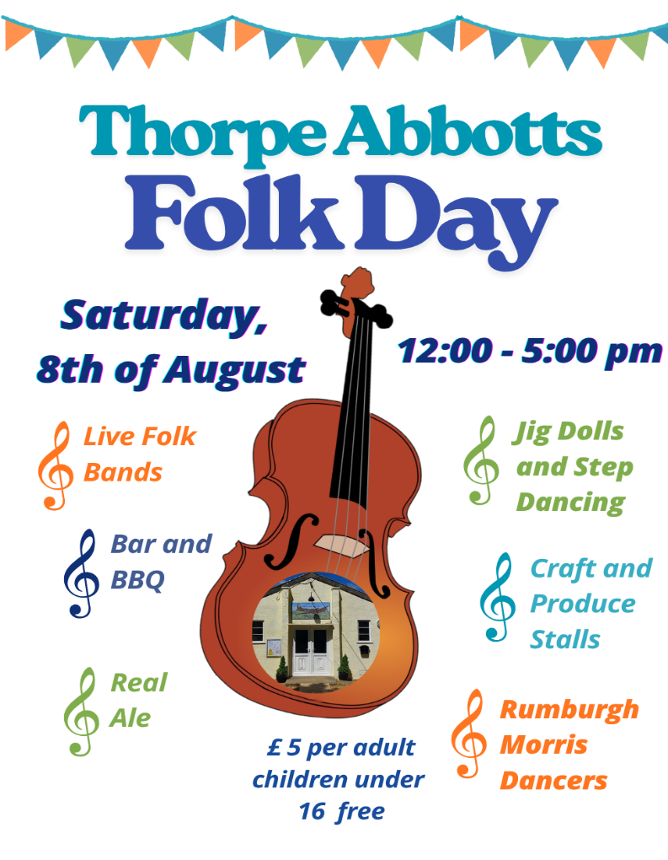
We are hoping that our willing team of cake and savoury bakers will be contributing to the Tea, Coffee and Cake Tent.

If you can help, please speak to Anne Shepherd or Susan Bagley.
Your support would be greatly appreciated!

Simon and Sarah are running the Produce Stall again.
Last year there was an abundance of fruit, vegetables, jams, preserves and other goodies!
Do let us know if you can “stock the stall” this year?
Thank you

And finally, the June Quiz was such a lovely evening, full of fun and laughter. Let’s hope that we can have another one before the end of the year!

See you on Saturday August 8th for the Folk Day

With best wishes.

Thorpe Abbotts Village Hall Management Committee

