Thorpe Abbotts Village Hall Newsletter 24 April 2026

Welcome to the April Newsletter from Thorpe Abbotts Village Hall. During the first four months of this year, it has been very busy. Non-stop at times for members of the Committee!
The highlights have been the wonderful talk on Tales from the Hive, the Easter Events and the Waveney Hillseekers Cycling event that saw the hall bursting at the seams both inside and out!
It was a privilege to hire the hall to such a community minded group and although it was very busy it was great to see the hall being used to its capacity.

As we are almost heading into May the first Coffee Morning on Thursday May 14th will also include the Plant Fair and a Raffle for Motor Neurone Disease (MND). Please note that the Coffee Morning has been moved to the second Thursday of this month due to the local elections on May 7th.


There are two key events in June that we hope will be of interest. The first being the Thorpe Abbotts Pop Up Museum will be part of the monthly Coffee Morning on Thursday June 4th starting at 10.30am – 12.00pm, 2.00-4.00pm and then 6.00-8.00pm. This is a one- day exhibition which will offer something different to come along to and will include items from Gary Alderton personal collection. Come along and about learn about the village and the surrounding area from fossils to present day artifacts. Perhaps you have something you can add to the exhibition. If so do contact Gary on 01379 668537.
What has been Discovered? Uncovered and Dug Up about where we live?

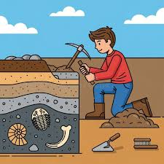


The second is the Thorpe Abbotts Village Hall Quiz Saturday June 13th, 7.00pm start in aid of the Village Hall Funds
“Two people are born at the same moment, but they have different birthdays. How can this be?”
This will be one of the questions at the quiz!! You’ve got time to find the answer and win a prize!!
Tables of Six - £5 per person – please book by emailing Carol Hitchman at carolhitchman17@gmail.com The bar will be open with snacks and nibbles

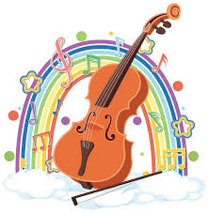

Thorpe Abbotts Folk Day Saturday August 8th 12.00-5pm
Do come along and join us on the first Thorpe Abbotts Folk Day.
There will be lot to see and listen to along with craft stalls and activities for the children.
Cost: £5.00 per adult and children under 16 are free

The Future of the Village Hall
As we have mentioned in our previous newsletters we now almost at the point where we will be inviting the residents of the Thorpe Abbotts to a consultation about the future of the hall.
Reaching this stage has taken the Committee some time in the planning as we have been keen to be able to provide you with as much information as possible so that you can make an informed decision.
Next months Newsletter will be giving further information.

With very best wishes, The Village Hall Committee

